Honors Physics Final Exam Review – Spring 2019
Vocabulary
Alternating Current
Ammeter
Ampere
Amplitude
Antinode
Attraction
Battery
Beat
Capacitor
Charge
Circuit
Circuit Breaker
Color Addition
Color Subtraction
Complementary Colors
Compression
Concave Lens
Concave Mirror
Conduction
Conductor
Conservation of Charge
Convex Lens
Convex Mirror
Cornea
Coulomb
Coulomb’s Law
Crest
Critical Angle
Current
Decibel (dB)
Decibel Scale
Diffraction
Diffuse Reflection
Direct Current
Doppler Effect
Dry Cell
Dye
Echo
Electric Field
Electric Field Line
EM Spectrum
Electromagnetic Wave
Electron
Electrostatics
Equivalent Resistance
Frequency
Fundamental Frequency
Fuse
Grounding
Harmonics
Hyperopia
Illuminated
Incident Wave
Induction
Infrasonic
Insulator
Intensity
Interference
Law of Reflection
Lens
Light
Lightning
Longitudinal Wave
Loudness
Luminous
Mechanical Wave
Mirror
Myopia
Node
Noise
Ohm
Ohm’s Law
Opaque
Oscillation
Parallel Plate Capacitor
Parallel Circuit
Period
Periodic Motion
Pigment
Pitch
Polarization
Potential Difference
Power
Primary Color
Pupil
Rarefaction
Ray Diagram
Real Image
Reflected Wave
Reflection
Refraction
Repulsion
Resistance
Resistor
Resonance
Retina
Secondary Color
Series Circuit
Short Circuit
Simple Harmonic Motion
Snell’s Law
Sound
Standing Wave
Total Internal Reflection
Translucent
Transparent
Transverse Wave
Trough
Ultrasonic
Vibration
Virtual Image
Volt
Voltage
Voltmeter
Wave
Wavelength
Wave Pulse
Wet Cell

Work

Important Concepts:

- Name the subatomic particles: their charge, location in the atom and the electrostatic behavior.
- Compare and contrast electrostatic force and gravitational force.
- Explain how a neutral object may be charged through friction, conduction and induction.
- Determine why a neutral object will be attracted to a charged object, but not repelled by a charged object.
- State the Conservation of charge and give an example.
- Analyze Coulomb’s Law: if distance is greater how does the force respond? If charge is greater how does the force respond?
- Define electric field and explain how to draw an electric field diagram.
- Discuss the difference between electrical potential difference and electric potential energy.
- Compare and contrast series and parallel circuits.
- Analyze Ohm’s Law: if voltage is constant what happens when resistance is increased? If resistance is held constant what happens if voltage is increased? Explain the type of relationship demonstrated in these situations.
- Compare and contrast an electric field and a magnetic field.
- Define the types of waves and the components of each type. Draw a diagram to illustrate each type of wave.
- Explain what happens in each of the following situations: a mechanical wave encounters a boundary, an EM wave strikes a transparent object, two out of phase waves occupy the same space at the same time and two in phase waves occupy the same space at the same time.
- Discuss the changes in the speed of sound when it travels through different phases of matter.
- Explain how temperature changes the speed of sound that is traveling through a gas.
- Define resonance and give two examples.
- List the waves on the Electromagnetic Spectrum by increasing frequency. Describe what happens to the amount of energy as the frequency increases and to the wavelength as the frequency increases.
- Compare and contrast sound waves and light waves.
- Explain why we see certain colors.
- Discuss the difference between color addition and color subtraction.
- State the Law of Reflection and give an example.
- Explain what changes occur when light enters a new medium.
- Define critical angle and total internal reflection
- List the types of mirrors and the LOST characteristics for the images formed by each mirror.
- List the types of lenses and the LOST characteristics for the images formed by each lens.

Problems:
List the information given, the unknown and the formula. Show your work!
- What is the electric field 3.5 x 10¹ m from a charge of 3C?

- What is the magnitude of the force of a 10µC charge exerts on a 3.0µC charge 2.0 m away?

- A 4.5x10⁹ C charge is located 3.2 m from a 2.8x10⁹ C. Find the magnitude of the electrostatic force by one charge on the other.

- A 50.0-V battery is connected across a 10.0-ohm resistor and produces a current of 4.5 A.
What is the internal resistance of the battery?

5. How much voltage is required to make 4 amperes flow through a 12-ohm resistor?

6. A battery does 18 J of work on 10 coulombs of charge. What voltage does the battery supply?

7. What is the current in a 60-W bulb connected to a 120-V source?
8. Find the current through a 12-ohm resistive circuit when 24 volts is applied.

9. Find the applied voltage of a circuit that draws 0.2 amperes through a 4800-ohm resistance.

10. Find the applied voltage of a telephone circuit that draws 0.017amperes through a resistance of 15,000 ohms.

11. A series circuit has 1200-ohms of total resistance with 12 V as the power supply. What is the total current of
this circuit?

12. A 35-Ω, 55-Ω, and 85-Ω resistor are connected in parallel. The resistors are then connected to a 35-V
battery.
a. What is the equivalent resistance of the parallel combination?
b. What is the current through each resistor?

13. The load across a 50.0-V battery consists of a series combination of two lamps with resistances of 125 Ω and
225Ω.
a. Find the total resistance of the circuit.
b. Find the current in the circuit.
c. Find the potential difference across the 125-Ω lamp.

14. A sound wave traveling at 350 m/s has a frequency of 500 Hz. What is its wavelength?

15. A sound wave travels 2.462 km in 8.73 s. What is speed of the wave?

16. An electromagnetic wave travels for 21.38 ms. How far does it travel in kilometers?

17. What is the frequency if you bounce a ball 27 times in 20 seconds? What is the period?

18. What is the wavelength in meters of the sound produced by a tuning fork which has a frequency of 320 Hz?
The temperature of the air is 15°C.

19. A candle is placed 15 cm from a concave mirror that has a focaI length of 10 cm. Where is the image
located? What is the magnification?

20. A 2.0 cm flame forms an image at 12 cm when the candle is located at 12 cm. What is the focal length of the
Mirror? What is the height of the image?

21. Explain why you did not need to perform any calculations to solve problem #20.

22. A candle is placed 15 cm in front of a diverging lens which has a focal length of 10 cm. Where is the image
located? What is the magnification?

23. What is the angle of refraction for a ray of light striking the water at an angle of 30°?

24. What is the critical angle for a ray of light leaving water and entering air?
25. What is the speed of light in water?

Diagrams

Name the type of circuit shown below. Calculate the total resistance, current and the voltage drop across each resistor.

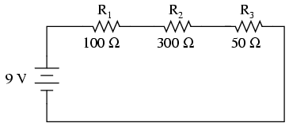

Name the type of circuit shown below. Calculate the total resistance and the current through each branch.

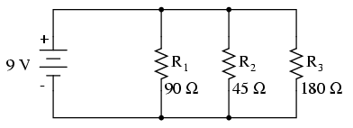

Two neutral conducting pop cans are touching each other. A positively charged balloon is brought near one of the cans as shown below. The cans are separated while the balloon is nearby, as shown. After the balloon is removed the cans are brought back together. When touching again, can X is ____.

Identify the wave, label all components, measure and record the amplitude, frequency and wavelength.

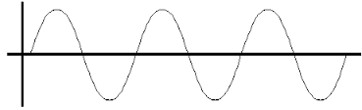

Label the wave type and all components

Determine the color created in each situation.

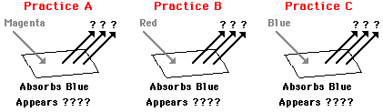

Explain the process indicated below

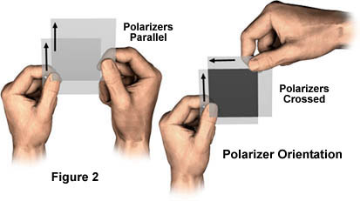

In the diagram below, the incident ray is equal to 32°. What is the reflected angle?

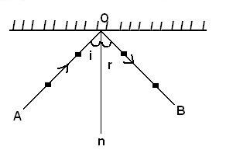

Label the medium that is more optically dense. Conceptually justify your answer. Measure the angles with a protractor. Use Snell’s Law to determine the index of refraction value of Medium #2 if Medium #1 is air.

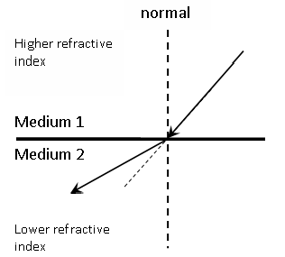

Label each diagram with the correct optical instrument and list the LOST characteristics.

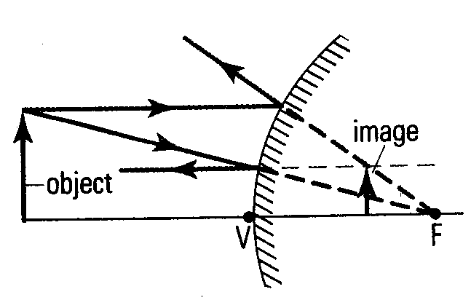

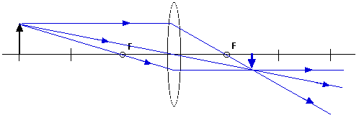

Determine the vision problem experienced by the eyeball below. What lens is needed to correct the issue?
