Physics Review Guide – Spring 2019

Electrostatics

Attraction
Charge
Conduction
Conductor
Conservation of Charge
Coulomb
Coulomb’s Law
Electric Field
Electric Field Lines
Electric Force
Electric Potential Difference
Electric Potential Energy
Electron
Electroscope
Electrostatics
Friction
Grounding
Induction
Insulator
Lightning
Negatively Charged
Neutral
Ohm
Ohm’s Law
Polarization
Positively Charged
Proton
Repulsion
Static Electricity

- What is the magnitude of the electrostatic force between a 6.2 C charge and 3.4 C charge that are separated by a distance of 4.3 x 10⁻³ m?
- If a distance of 1 km separates two electrons, what would be the electrostatic force between them? (Hint: charge on an electron is -1.6 x 10⁻¹⁹ C)
- The electric field strength in a given area is 2200 N/C. What is the force exerted on an object with the charge of 0.004 C?
- The electric field in a particle accelerator machine is 4.5 x 10⁵ N/C. How much work is done to move a proton (1.6 x 10⁻¹⁹ C) 15 cm through that field?
- In the diagram below, rank the field strength of each letter from least to greatest. Justify your answer.

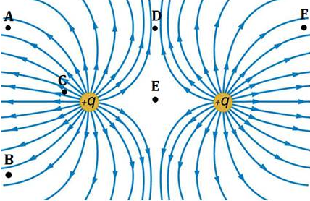

- In the diagram below, determine the charge of each particle. Justify your answer.

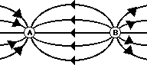

- Label the method used for charging the object and explain the process.

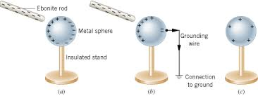

Electricity

Alternating Current
Ammeter
Ampere
Battery
Circuit
Circuit Breaker
Current
Direct Current
Electric Potential Difference
Equivalent Resistance
Fuse
Generator
Kilo-watt hour
Load
Motor
Parallel Circuit
Power
Resistance
Resistor
Series Circuit
Short Circuit
Volt
Voltage
Voltmeter
Watt

- A portable compact disc player is designed to play for 2 hours on a fully charged battery pack. If the battery pack provides a total of 180 C of charge, how much current does the player use while operating?
- You light a light bulb with 1.5 V battery. If the resistance of the light bulb is 10 Ω, how much current is flowing through the bulb?
- Calculate the power usage of a light bulb that is connected to a 1.5 V battery. The resistance of the bulb is 3.0 Ω.
- Three resistors, 4.0 Ω, 5.0 Ω and 7.0 Ω, are connected in a series circuit.
a. What is the total resistance of the circuit?
b. If the circuit is connected to a 9.0 V battery, what is the total current in the circuit?
c. What is the voltage drop across the 7.0 Ω resistor?
- Three resistors, 4.0 Ω, 5.0 Ω and 7.0 Ω, are connected in a parallel circuit.
a. What is the total resistance of the circuit?
b. If the circuit is connected to a 9.0 V battery, what is the total current in the circuit?
c. What is the voltage drop across the 7.0 Ω resistor?
- Label the type of circuit below and the component represented by each symbol.

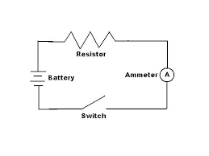

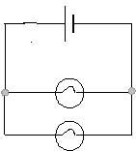

- Which wire has the least resistance? Justify your answer.

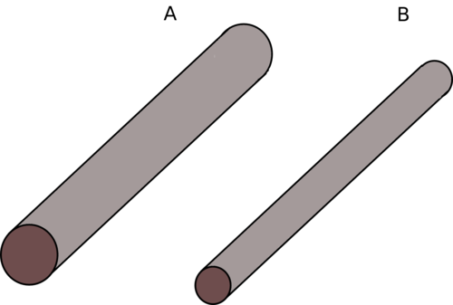

Magnetism

Attraction
Compass
Electromagnet
Ferromagnetic
Lodestone
Magnetic Domain
Magnetic Field Lines
North Pole
Permanent magnet
Repulsion
South Pole
Temporary Magnet
Tesla

- Label the North Pole and the South Pole on the diagram below. Justify your answer.

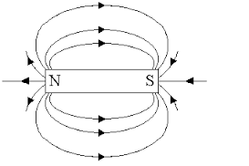

- A bar magnet is cut in half. Identify and draw the new poles on the magnet pieces.

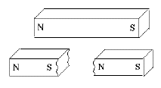

- Identify the item in the diagram below and explain how it works.

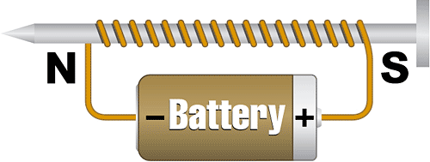

Waves

Amplitude
Compression
Constructive Interference
Crest
Destructive Interference
Diffraction
Electromagnetic Wave
Energy
Equilibrium
Frequency
Hertz
Incident Wave
Interference
Longitudinal Wave
Mechanical Wave
Medium
Oscillation
Period
Periodic Motion
Rarefaction
Reflected Wave
Reflection
Refraction
Simple Harmonic Motion
Sine Curve
Standing Wave
Transverse Wave
Trough
Vibration
Wave
Wavelength
Wave Pulse

- A guitar string makes 80 vibrations in 8 seconds. Calculate the frequency and the period.
- If the time it takes for a wave to complete one cycle doubles, what happens to the frequency of the wave?
- A typical light wave has a wavelength of 580 nm. What is the frequency of this wave?
- A transverse wave has a frequency of 125 Hz. If the velocity of the wave is 220 m/s what is the wavelength?
- A wave travels 1.23 km. If the speed of the wave is 375 m/s how long did it take for the wave to travel this distance?
- Label the type of wave and all components. Measure the wavelength and the amplitude of the wave.

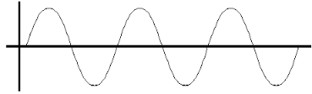

- Label the wave type and all components. Measure the wavelength.

- In the diagram below determine which
- wave has the greatest amplitude
- wave has the shortest wavelength
- wave has the lowest frequency
- which two waves are in phase and the amplitude of the resultant wave

A B C

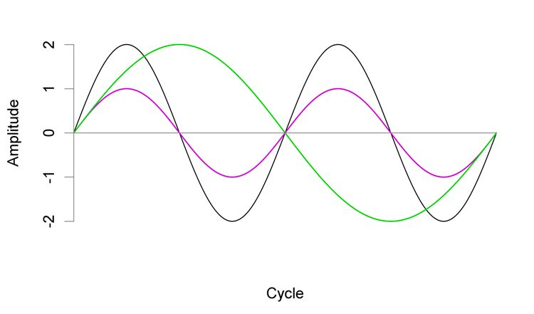

Sound

Antinode
Beat
Closed-End Air Column
Compression
Decibel (dB)
Decibel Scale
Doppler Effect
Echo
Fundamental Frequency
Infrasonic
Intensity
Longitudinal Wave
Loudness
Node
Noise
Octave
Open-End Air Column
Oscillation
Pitch
Rarefaction
Resonance
Sound
Standing Wave
Ultrasonic

- An A note is played a 440 Hz. If the temperature in the room is 18ºC what is the wavelength?
- You stand on the edge of a canyon and shout, 3.2 seconds later you hear your echo. If the temperature of the air is 22 ºC how wide is the canyon?
- You have 3 tuning forks available; 441 Hz, 443 Hz, and 437 Hz. Identify all the beat frequencies can you produce by playing any two of them at the same time.
- A police siren has a frequency of 500 Hz. The police car is involved in a high speed chase and is moving east with a speed of 50 m/s. The temperature is 22° C.
  - What frequency does someone at rest hear as the police car is approaching them?
  - What frequency do they hear as they the police car moves away from them?
- The speed of sound waves in air is found to be 340 m/s. Determine the fundamental frequency of an open-end air column that has a length of 67.5 cm.
- A closed-end pipe is capable of sounding out a first harmonic of 349.2 Hz. The speed of sound in the pipe is 350 m/sec. Find the length of the air column inside the pipe.
- Identify the type of wave below. Label the nodes and antinodes.

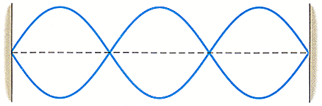

- If the length of the string in the diagram above is 15 m, what is the wavelength measurement?
- Label the parts of the ear and explain how someone hears a sound.

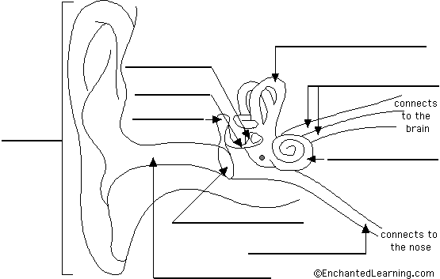

Light and Color

Absorption
Angle of Incidence
Angle of Reflection
Angle of Refraction
Color Addition
Color Subtraction
Complementary Colors
Cones
Dye
EM Spectrum
Electromagnetic Wave
Illuminated
Incident Ray
Index of Refraction
Intensity
Law of Reflection
Luminous
Normal
Opaque
Penumbra
Pigment
Polarization
Primary Colors of Light
Primary Colors of Pigment
Prism
Reflected Ray
Reflection
Refracted Ray
Refraction
Retina
Rods
Secondary Colors of Light
Secondary Colors of Pigment
Shadow
Snell’s Law
Speed of Light
Translucent
Transmission
Transparent
Umbra
Visible Light
White Light

- What is the frequency of an EM wave that has a wavelength of 3.2 x 10⁻⁹ m?
- The distance from the Earth to the sun is 1.496 x 10¹¹ m. A solar flare occurs on the sun’s surface on Wednesday morning at 10:24 AM. At what time will electromagnetic radiation from the flare reach the Earth?
- Light is incident at 20° to the normal. What is the angle of reflection?
- A ray of light is traveling from air to water at an angle of 33°. If n = 1.33 for water, what is the angle of refraction?
- What is the speed of light in a diamond (n = 2.42)?
- If the speed of light in ethanol is 2.2 x 10⁸ m/s, what is the index of refraction for ethanol?
- What is the critical angle for light traveling from water to air?
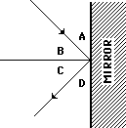
- Consider the diagram at the right. Which one of the angles (A, B, C, or D) is the angle of incidence? Which one of the angles is the angle of reflection? Complete the chart with each degree value.

Angle | Degree Value
A | 32°
B
C
D

- Analyze the diagram below to determine the following:
- medium that is the most dense
- what component is missing from the diagram
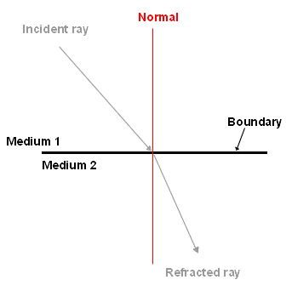

- Place the EM radiation in order on the spectrum. Label the area of lowest frequency and the area of highest energy.
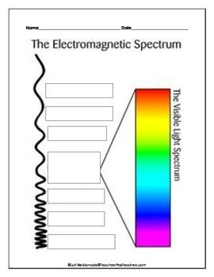

- Complete the Venn Diagram to indicate the primary colors of light and the resulting secondary colors when added.

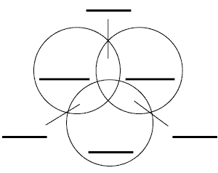
- Explain what is happening in the diagram below.

